LESSON NOTES FOR APTITUDE FOR TOP CLASS TERM I – 2026

Taking care of myself for proper growth ad development.
My name is ___________
I am ____ years old. I am a__________ (girl, boy)
My father’s name is _____________
My mother’s name is ____________
I live/stay at ____________
My school is ______________

Activity
- What is your name?
My name is _________________
- How old are you:
I am ________ years old.
I am a _______________(girl/boy)
Let the pupils talk about themselves.
- What’s your father’s name?
__________________________
- What’s your mother’s name?
_______________________
- Where do you live/stay?
_______________________
- What’s the name of your school?
___________________________
Drawing and describing his/her name.

Naming my body parts
- reciting/singing a rhyme about body parts.
- Naming and identifying body parts e.g ears, toes, nose, mouth, fingers, legs, eyes, lips, etc.
Teacher leads pupils to know how many they are.

All about functions of each body part e.g.
eyes - seeing
nose - smelling
legs - walking, etc
- Children should know the main function of body parts. i.e to give shape of person.
The teacher should lead the pupils to appreciate the gifts God gave us through a song, prayer, rhyme, etc

Lesson one
Activity
- Teach a dialogue song about body parts (oral)
- Naming body parts.
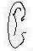 | 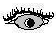 | 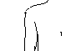 | 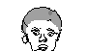  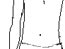 | 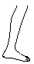 | 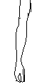
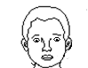 | 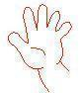 | 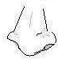

Lesson two
Matching body parts to their uses.

walking

hearing

seeing

smelling
touching

Lesson three
Filling in missing letters
e__r n__se __ye le__

h__ir stom__ch han__

Lesson four
Write these words correctly.
era _______ seno _________ eey _______
ige _______ teos _________ ngerfi _________

Joining a puzzle
- face fingers leg hand ear

Caring for our body
Reciting a rhyme about the ways of caring for our body.

Teacher guides children and instructs them to mention the way how different body parts are cared for. e.g
teeth - by brushing
fingernails - by cutting them short
hair - by combing, cutting, plaiting, etc.

Activity
How can you care for your teeth?
I can care for my teeth by _______________

Draw these things we use to cut finger nails.

- razorblades (ii) nail cutter

Match correctly
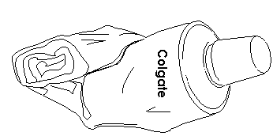
toothbrush

comb


razorblade

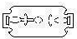
toothpaste

Talk about the importance of keeping our body clean e.g It makes us look smart, etc.
Talk about the dangers of cleaning the body. e.g It causes bad smell.

Lesson 6
I can locate the place where I live/stay
I live/stay at __________
My village is _____.
My home is found at __________________

Tings that make up a home.
kitchen
toilet
bedroom
bathroom
sitting room

Activity
Name the things found in the kitchen e.g saucepan, spoon, plates.
Where do we ease? (oral)
chairs, cupboard, table, carpet, television, (TV), radio, etc
Write the things we find in a bedroom. e.g bed, basin, wardrobe, mattress, blanket, pillow, suitcase, etc

Family members
recite a rhyme/sing a song about family members.
Mention family members (nuclear family) e.g father, mother, sister, brother, baby

Other family members extended family)
- aunt
- uncle
- cousin
- nephew
- grandfather
- grandmother

Activity
Who heads a family?
________heads a family.
Name these people found at home.
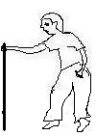 | 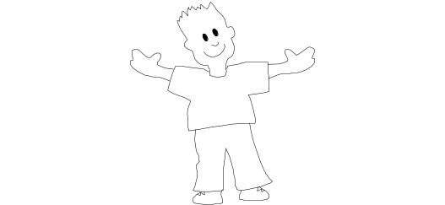  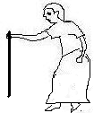

Fill in the missing letters
f__ther m__ther si__ter br_ther

Colour these family members

Animals found at home.

- pig
- goat
- dog
- sheep
- cow
- rabbit

Activity
Write these words correctly.

pgi - _______
gdo - _______
oatg - _______
atc - _______
woc - _______
eepsh - _______
bbitra - ________

Read and draw
pig | dog | cow | sheep | rabbit | cat

Fill in missing letters.
sh__ __ p go__t c__w rab__it c__t
- Telling the role of each of the animal found at home.

Birds found at home. e.g duck , hen, turkey

Activity
Read and draw the birds.
What does the hen give us?

Fill in the missing letters.
h__n d__ck tu__key

Roles of family members
Tr. guides the children to discuss and discover the roles of different members e.g
Mother Father Children
- Cooks food - heads a family - Mop the house
- feeds the baby - Buys food etc - Sweep the compound
- Cleans the home - Wash dishes, etc
- Mops the house, etc

Activity
Pupils’ role play
- Draw Mummy cooking food

Name the things we use to clean the home.

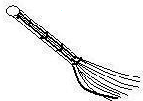
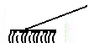
____________ __________
Lesson eight

Domestic animals which are not eaten.
dog
donkey
horse
camel

Use of animals (Things we get from domestic animals)
cow - milk, meat, dung, skin
goat - meat, milk, skin
dog - keeps/guards homes, it is a pet
sheep - milk, wool, manure
cat- eats rats, It is a pet
Activity

- Which animal guards the home? ____________________

Match correctly
cow wool
dog milk
sheep guards our homes

- Which animals eats rats from the house?_____________________
Animals used for transport
donkey
horse For carrying people and things. They are also used as pets.
camel

Lesson nine
Uses of birds. (Things we get from birds)
hen - eggs, chicken, manure
duck - eggs, meat
turkey- eggs, meat
Activity
Draw these things we get from a hen.
eggs chicken

Lesson ten
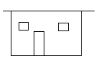
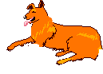
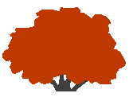
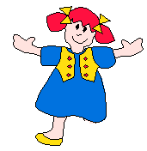
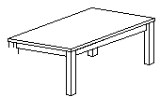
Fill in the missing parts

Complete the pattern
123 123______ IIO= IIO= IIO=

Lesson eleven
Revision
Complete all the learnt activities.

